Family Prayer Service for the Solemnity of St. Joseph, March 19

Supplies needed: Bible
Gather together around your Family Prayer Space/altar of St. Joseph. When all are ready, make the Sign of the Cross.
Pray
Choose a Leader to read the Mass Collect for March 19:
Grant, we pray, Almighty God, that by St. Joseph’s intercession your Church may constantly watch over the unfolding of the mysteries of human salvation, whose beginnings you entrusted to his faithful care. Through our lord Jesus Christ, your son, who lives and reigns with you in the unity of the Holy Spirit, one God, for ever and ever. Amen.
Read
Choose another leader to read the passage from Luke 2:41-51a (older children)
Read the story of Jesus being lost and found in the Temple (for younger children)

Discuss:
How do you think St. Joseph felt the moment he heard Jesus was missing?
How do you think St. Joseph felt when he saw Jesus in the Temple? Do you think it affected their relationship? St. Joseph models the love God the Father has for each of us. How do you think God feels when we are far from him? Does it affect our relationship? Is there a part of your life where you, as Jesus showed us, need to be more obedient?

Pray
Choose a leader to read:
Dear St. Joseph, you watched with love and faithfulness over your family in Nazareth. You heard with concern the prayers of those in Italy, suffering with drought, and came to their aid. Watch over our family, gathered here today in your honor. Hear our prayers, too, St. Joseph, (Add your own personal prayers to St. Joseph, either sharing aloud or in silence ) and keep us close to Mary, our Mother and your Spouse, and her Son. Our Lord Jesus Christ, all the days of our lives, so that we, too, may pass onto our heavenly home in peace, when our work here on earth is done. Amen.

Optional:
Pray the Litany of St. Joseph together. Choose one leader or take turns reading the invocations to St. Joseph. All respond.

Lord, have mercy. Lord, have mercy.
Christ, have mercy. Christ, have mercy.
Lord, have mercy. Lord, have mercy.
Christ, hear us. Christ, graciously hear us.
God, the Father of Heaven, Have mercy on us.
God the Son, Redeemer to the world Have mercy on us.
God, the Holy Spirit, Have mercy on us.
Holy Trinity, One God, Have mercy on us.

Holy Mary, pray for us.

Saint Joseph, pray for us.
Renowned offspring of David, pray for us.
Light of Patriarchs, pray for us.
Spouse of the Mother of God, pray for us.
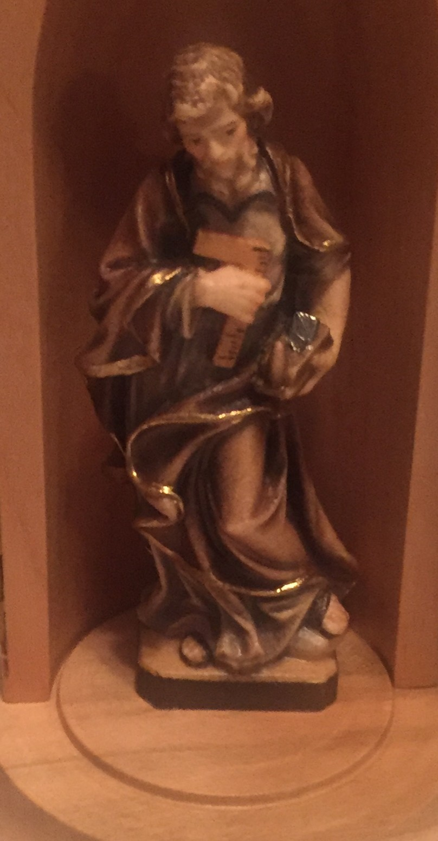
Chaste guardian of the Virgin, pray for us.
Foster father of the Son of God, pray for us.
Diligent protector of Christ, pray for us.
Head of the Holy Family, pray for us.
Joseph, most just, pray for us.
Joseph, most chaste, pray for us.
Joseph, most prudent, pray for us.
Joseph, most strong, pray for us.
Joseph, most obedient, pray for us.
Joseph, most faithful, pray for us.
Mirror of patience, pray for us.
Lover of poverty, pray for us.
Model of all who labor, pray for us.
Glory of family life, pray for us.
Guardian of virgins, pray for us.
Pillar of families, pray for us.
Consolation of the afflicted, pray for us.
Hope of the sick, pray for us.
Patron of the dying, pray for us.
Terror of demons, pray for us.
Protector of holy Church, pray for us.

Lamb of God, who takes away
the sins of the world, spare us, O Lord.
Lamb of God, who takes away
the sins of the world, graciously hear us, O Lord.
Lamb of God, who takes away
the sins of the world.
He made him the lord of
His household, and prince over all his possessions.

Let us pray:
O God, in Your ineffable providence You were pleased to choose Blessed Joseph to be the spouse of Your most holy Mother; grant, we beg You, that we may be worthy to have him for our intercessor in heaven whom on earth we venerate as our protector; You who live and reign forever and ever. Amen.

The Litany of St. Joseph was approved for public use by Pope St. Pius X in 1909. Like other litanies, this litany contains 21 invocations to Saint Joseph which describe his virtues and the part he played as the foster father of Jesus. The Litany has a partial indulgence attached to it.

©2019 the Strawberry Vine. All rights reserved.

